

When fabric head mark as approve then fabric details like inv code, qty, unit price item amount fields should be locked
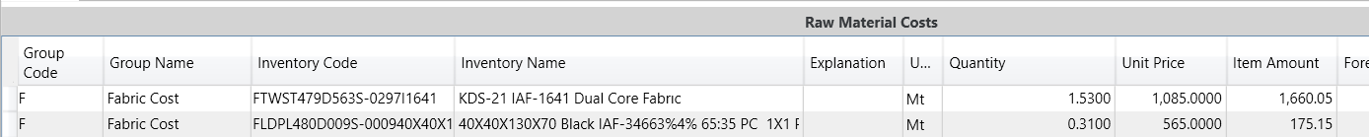


When MMC head mark as approve then trims details will be lock
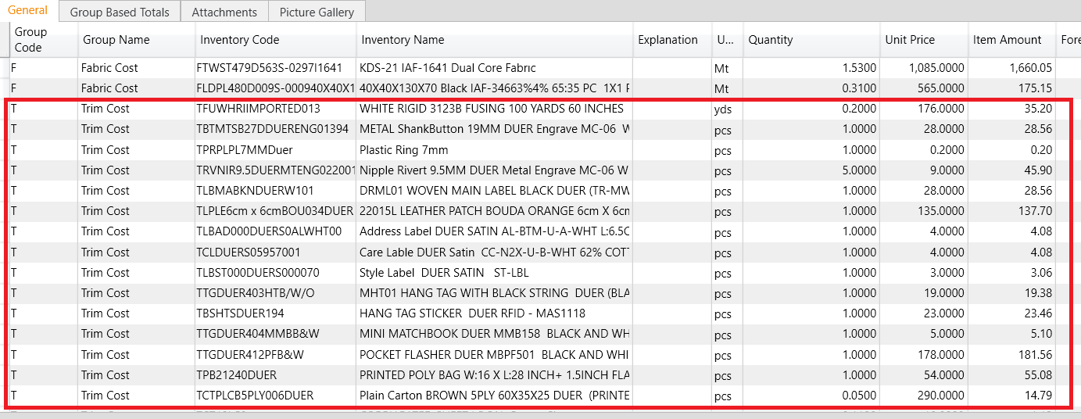


When IE head approve then Sewing, washing, finishing and cutting SAM will be lock
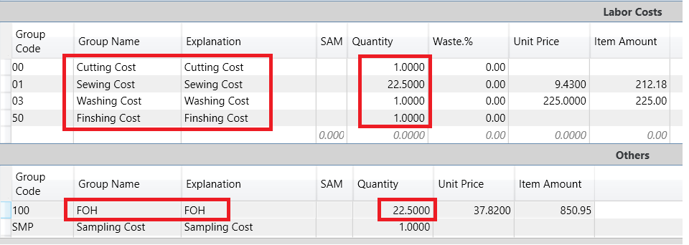


When washing head approve then washing unit price will be lock for others
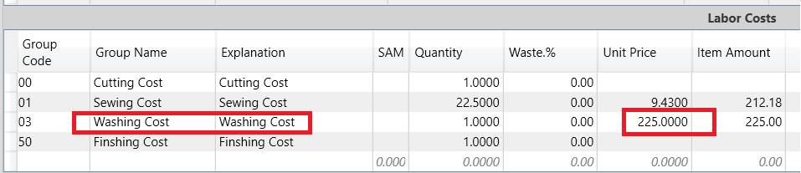

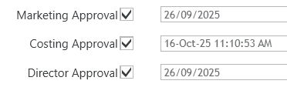
At end Marketing approval after that Costing head and then Director approval will be follow.

